Press release

Contact

Biral will be presenting its products and services at ISH 2017 in Frankfurt

All you need
Comprehensive, useful, target-focused, liberating: These four as- pects of the company philosophy will be at the centre of Biral’s presence at the ISH trade fair.

Under the motto “All you need”, in Frankfurt the leading Swiss pump manufacturer will present its comprehensive support services, the wide range of Biral products with a standardised control concept, the Biral campus, the vastly modernised website and the useful online services for experts. The company will also demonstrate its new pressure-boosting systems, the new Biral AX... BLUE high-efficiency recirculation pump with the smallest possible connection thread and other new products at ISH.

ComBo
At ISH 2017, Biral will present the ComBo compact pressureboosting system based on the horizontal multistage high-pressure pump BM-E and the ComBo HP-E with one to four multistage vertical high-pressure pumps. These two new compact boosters from Biral are established combos with up to four pumps which can recognise your piece without a conductor: Thanks to the new frequency inverter, master controls which orchestrate the cascade are no longer needed as the drive units manage themselves. The Biral ComBo systems are used, for example, in single- occupancy or holiday homes with an insufficient or fluctuating mains pressure.

Biral AG
Südstrasse 10
CH-3110 Münsingen Switzerland
T +41 (0)31 720 90 00
F +41 (0)31 720 94 43
Rosmarie Danz r.danz@biral.ch www.biral.ch

Press release

Contact

The compact systems provide maximum quality and uncompromising comfort in the area of small pressure boosting systems or domestic water supply systems.

Biral AG
Südstrasse 10
CH-3110 Münsingen Switzerland
T +41 (0)31 720 90 00
F +41 (0)31 720 94 43
Rosmarie Danz r.danz@biral.ch www.biral.ch

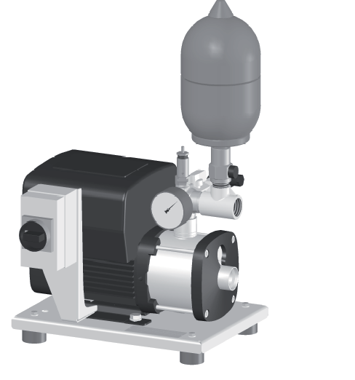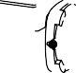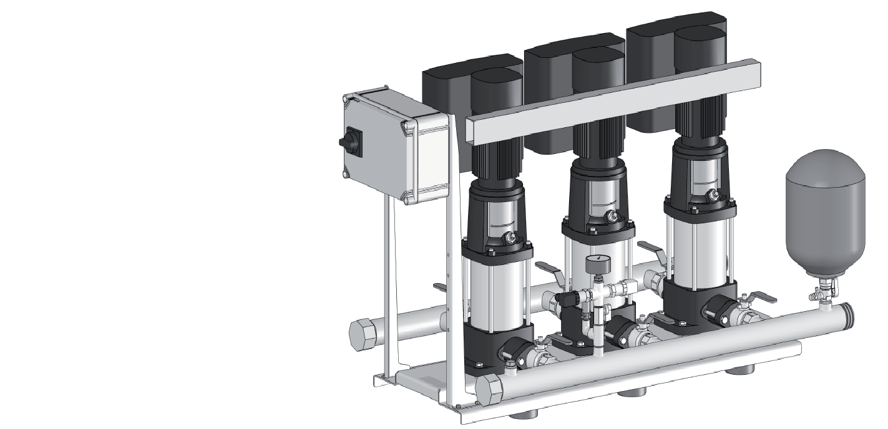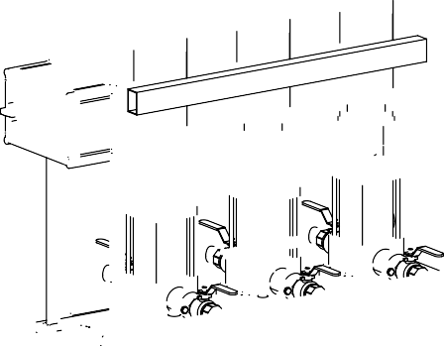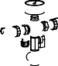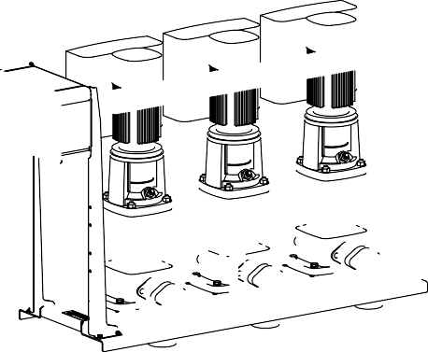ComBo easy ComBo HP-E

AX... BLUE
Biral is also providing top quality with the AX... BLUE. The drinking water circulation pump previously known as the AXW 15 was given its new name as part of a move to standardise product names. Thanks to selecting the smallest possible con- nection thread with a nominal diameter of 15 mm, reducers are no longer requi- red over several nominal diameters. The AX... BLUE features a non-return val- ve and a stopcock, which means that the motor can be installed and removed without having to drain the entire circula- tion system.

BIM B3 Module
Biral will present the Biral interface modu- le BIM B3 at ISH as the successor to the BIM B2. The new add-on module now enables operating and ready messages to be called up and has additional profiles for external control. The BIM B3 can now be used to adjust the rotational speed of the pump remotely and to set target va- lues.

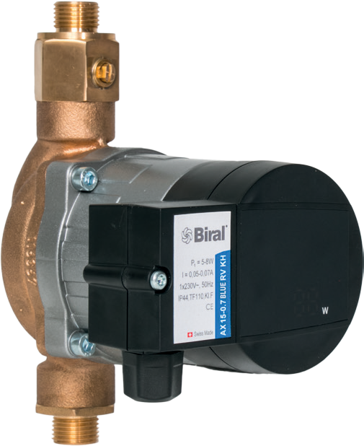
AXW... BLUE

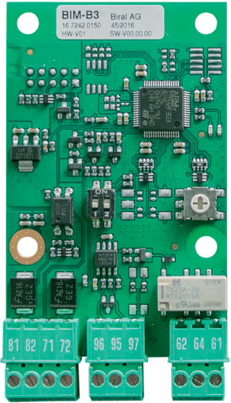
BIM B3

Press release

Contact

Biral with a new website
The new Biral website is responsive and thus optimised for all standard devices. It provides Biral customers with an efficient full text search feature, the option to search for a direct contact by postcode and a direct search function for exchanging a pump: In just two clicks, you can find out which pump you need to replace a defective or old device. Thanks to the new quick links, you can access the online tools in just one click: The PumpSelector, tenders and the CAD Finder. The “Jobs” category and the popular eDocuments tool can also be controlled directly. The new Biral website provides a wealth of information and online services, whereby this extensive range of products and services is presented in a refreshingly simple and clear manner.

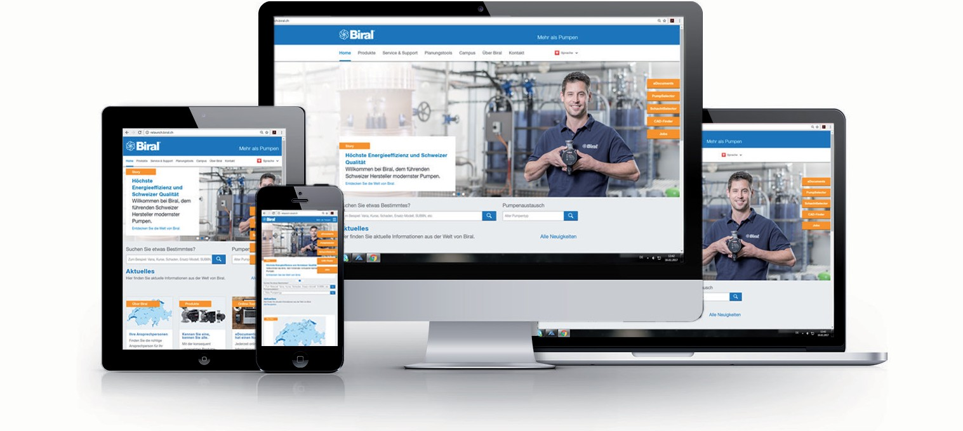

eDocuments - now in HTML 5
Last but not least, Biral’s new eDocuments tool is also liberating: The interface now works without Adobe Flash, which means that in practice, this popular program can also be used on tablets, smartphones and on computers without a preinstalled Flash plugin. Planners and installers can now access product-related information from the Biral Group at any time and online on various output devices. Not only can you read the published content online and download it, you can also combine the pages of any document and send it via e-mail or download it as a personalised PDF file. The new HTML5 solution enables numerous zoom levels right through to a full-screen mode, the side view lets you rotate by 90 degrees and a miniature page overview makes navigation easier.

Biral AG
Südstrasse 10
CH-3110 Münsingen Switzerland
T +41 (0)31 720 90 00
F +41 (0)31 720 94 43
Rosmarie Danz r.danz@biral.ch www.biral.ch

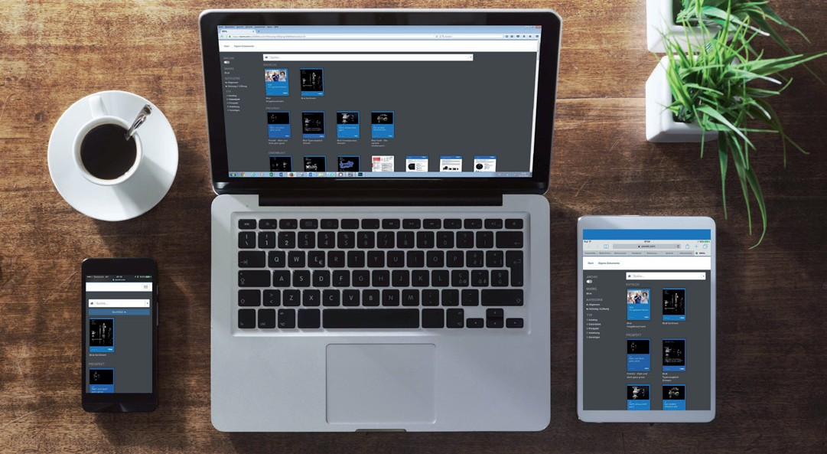

Press release

Contact

Comprehensive
«We offer Swiss quality and extremely easy handling»

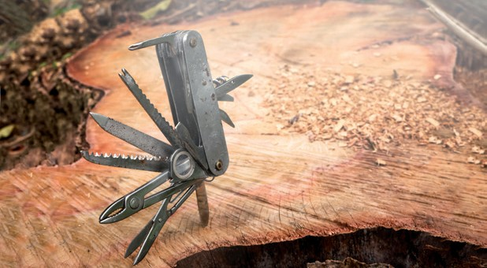Biral provides you with Swiss quality and a standardised control concept across the entire product range. Once you know one Biral pump, you can use and appreciate them all.

Useful
«We will shed light on darkness»

Biral will expand your horizons: At the Biral campus, we will provide you with basic and advanced training, as well as a platform for open discussion among specialists.

From autumn 2017, the Biral campus will also be available in Aachen.

Target-focused
«We will show you the way»

Biral will help you to reach your goal: Fostering close relationships with our customers is extremely important to us and we guarantee to be readily available for advice and support. You can contact us at any time.

Liberating
«We will support you with useful tools aimed at increasing efficiency and effectiveness»

Biral can offer you the best tools for the best solutions. Benefit from an extensive range of products online, including our planning tools and from practical resources for everyday life.

Biral AG
Südstrasse 10
CH-3110 Münsingen Switzerland
T +41 (0)31 720 90 00
F +41 (0)31 720 94 43
Rosmarie Danz r.danz@biral.ch www.biral.ch

